A Project Report
On
Prediction of High Temperature Deformation Behaviour of β-Titanium Alloy using Various Machine Learning Approaches

SUBMITTED IN PARTIAL FULFILMENT OF THE REQUIREMENTS OF
LABORATORY PROJECT (ME F366)
by
Ankit Ashok (2019B4A40452H)

under the supervision of
Dr. Kurra Suresh
Assistant Professor, Department of Mechanical Engineering


BIRLA INSTITUTE OF TECHNOLOGY AND SCIENCE PILANI HYDERABAD CAMPUS
(MAY, 2023)

Acknowledgements

I thank Dr. Kurra Suresh, who served as my project supervisor, for providing me with excellent direction and support. I would especially like to thank Dr. P Sandeep for all his help and guidance. I am appreciative that my department head, the director of the Hyderabad campus, and the vice chancellor of BITS Pilani gave me the chance to work on a project. Finally, I would like to thank my family for their continuous support.

- Ankit Ashok



Birla Institute of Technology and Science-Pilani, Hyderabad Campus

Certificate

This is to certify that the project report entitled “Prediction of High Temperature Deformation Behaviour of β-Titanium Alloy using Various Machine Learning Approaches” submitted by Mr. Ankit Ashok (ID No. 2019B4A40452H) in partial fulfilment of the requirements of the course LABORATORY PROJECT (ME F366), embodies the work done by him jointly under my supervision and guidance.

Date: 3 May 2023 (Dr. Kurra Suresh)
Assistant Professor
Department of Mechanical Engineering
BITS- Pilani, Hyderabad Campus

1. Abstract
Meta stable β-21S Titanium alloy is one of the most widely used titanium grade for making of high temperature resistant engine components. It can retain high strength even at higher temperatures. Thus it necessitates for understanding the deformation behaviour of the material under different processing conditions and its exact prediction using different mathematical models. Initially, the experimental flow stress behaviour of the material is studied by performing uniaxial tensile tests at various temperatures ranging from Room Temperature (RT) to 500 ºC and at different quasi-static strain rates of 0.0001, 0.001 and 0.01 S⁻¹. The flow stress is found be reduced with rise in temperature from RT to 300 ºC with strain softening and a significant rise in the flow curve is observed at 500 ºC which is expected due to the strain hardening of the material. A physical based modified Zerilli-Armstrong (m-ZA) model and five different machine learning models such as Ridge Regression (RR), Random Forest (RF), Extreme Gradient Boosting (XGB), Support Vector Regression (SVR) and Artificial Neural Network (ANN) models are implemented for the prediction of flow stress behaviour. The experimental tensile test data is used for the prediction of m-ZA constants. In case of ML models 70% of the available data is fed for training and remaining 30% is used for testing. Finally, the flow stress behaviour at 150 ºC and 0.001 S⁻¹ is predicted using the all the implemented models and found to good agreement with the experimental one. The ML models have shown better prediction over the physical based model. In particularly, the XGBoost model has shown the best prediction compared to all other models with Mean Absolute Percentage Error (MAPE) of 3.18% and 0.41 of Reduced Chi-Square. The ANN Model also gave good predictions with a MAPE of 5.5% and a reduced chi square of 0.99.
Keywords: β-Titanium; Flow Stress; Machine Learning; Physical Based; Modified Zerilli–Armstrong;

Table of Contents

A Project Report 1
Acknowledgements 2
Certificate 3
1. Abstract 4
Table of Contents 5
2. Introduction 6
3. Theoretical Modelling 7
3.1 Physical Based Model 7
3.2 Machine Learning (ML) Models 9
3.2.1 Ridge Regression (RR) 9
3.2.2 Random Forest (RF) 10
3.2.3 Extreme Gradient Boosting (XGB) 11
3.2.4 Support Vector Regression (SVR) 12
3.2.5 Artificial Neural Network (ANN) 13
4. Experimental Details 15
5. Results and Discussion 20
5.3 Validation of Results 24
5. Conclusions 26
References 27

2. Introduction
β-Titanium alloys are a class of materials that have risen in popularity in the past few decades due to the various attractive properties that they possess, namely its remarkable corrosion resistance, strength-to-weight ratio, biocompatibility, fatigue resistance, etc. Therefore, it has found cases in defence applications, aerospace, biomedical applications such as prosthetics [1]–[3]. These useful properties have led to an increased interest in researching the properties of the material, particularly its flow stress and hot deformation behaviour and how it affects the microstructure, yield strength, dynamic softening, etc. Previously, attempts have been made to model the behaviour of the material under different conditions using various mathematical models [4], [5].
The exact prediction of the material behaviour is difficult due to change in its microstructure during the deformation process, which needs a lot of investigation. Modelling its flow stress behaviour comes with complications that are difficult for a physical model to figure out. It exhibits significant anisotropy, which means that their properties can vary depending on the direction of loading. Further, the flow stress is highly non-linear, making it challenging to develop models that accurately predict the material's behaviour under different loading conditions. Its behaviour is significantly varied with changes in its temperature and strain rate, and has been extensively researched [6]. They also have a complex microstructure, which can vary depending on the processing history and composition of the material, thereby making it even more difficult for a model to truly capture its behaviour.
In recent years, Machine Learning (ML) has gained a lot of popularity due to the rise in computational resources, investment in developing ML libraries for easier implementations, thereby increasing accessibility [7]. Furthermore, it has shown an amazing ability to model complex relationships in various engineering applications. Deep learning methods such as the Multilayer Perceptron (MLP) implementation of an Artificial Neural Network (ANN) and kernel methods like Support Vector Machines (SVM) have been extensively used in various applications [8], [9]. Applying ML methods to model the behaviour of materials has found great success in the last few years. Stendal et al., [10] have investigated the application of ML to flow stress modelling of the TiAl alloy TNM-B1. Three models were developed: a phenomenological model (PM), a purely data-driven Machine Learning Model (MLM), and a Hybrid Model (HM) which combines the PM and the MLM. The MLM was shown to be faster to create and compute than the PM, more accurate than the PM, and able to capture the distinctive peak stress in TNM-B1. The HM and PM both demonstrated equivalent accuracy, but the HM was better able to construct a match for input conditions outside of the training data. Decke et al., have conducted a comparative study between the implementations of machine learning models and a ZA model in predicting the hot deformation behaviour of AA7075 [11]. They found out that, the ensemble learning methods provided the best performance, especially the XGBoost model, followed by the ANN, Linear Regression, kernel method (SVR) and finally the constitutive model (ZA). Cao et al., [12] have attempted to model the flow stress of Ni steel using a variety of physical models combined with optimization techniques and ML models. Once again, the ML models proved to be superior. These works show the efficacy and the need to further investigate which models perform better in predicting a materials behaviour, and whether one class of models can perform better than another.
Based on the above literature, very scarce literature has been found on the flow stress behaviour of β-21S alloy under different temperature and strain rate conditions. Also, on its flow stress behaviour prediction. In the present work, the experimental flow stress behaviour is investigated under different temperature and strain rate conditions. Also, a variety of ML models and a physical-based model is implemented and contrasted to show its ability in predicting the flow stress behaviour of β-21S alloy. The machine learning models’ performance is tested on both the test data that was split from the training data, as well as a validation data with completely distinct data. Thereby showing the models ability to perform on combination of parameters that are completely new, enabling researchers to depend on a reliable model rather than have to perform innumerable experiments.

3. Theoretical Modelling

3.1 Physical Based Model
The Zerilli–Armstrong (ZA) model is one of the common physically based constitutive models [13]. It is derived based on dislocation mechanisms which play an essential role in the plastic deformation of metallic materials under various deformation conditions. The model divides the flow stress into two components of thermal and athermal parts:
$σ=σ_{thermal}+ σ_{athermal}$ | (1)

The ZA model has a relatively simple expression compared to other dislocation-based constitutive models. The main characteristics of the model are that each material structure type will have a different expression due to the different strain rate controlling mechanism for the particular structure [13]. The thermal activation flow stress for BCC and FCC materials are given as:
$σ_{th}=C_{1}exp\left[-(C_{3}T+C_{4}Tln{\dot{ε}}^{*})\right]$ ( For BCC materials) | (2)

$σ_{th}=C_{2}E^{1/2}\left[-(C_{3}T+C_{4}Tln{\dot{ε}}^{*})\right]$ ( For FCC materials) | (3)

By combining the athermal activation stress and the effect of yield stress on grain size into one component C0, two different types of Z–A models can be expressed as:
$σ=C_{0}+ C_{1}exp\left[-C_{3}T+C_{4}Tln{\dot{ε}}^{*}+\left(C_{5}E^{n}\right)\right]$ | (4)

$σ=C_{0}+ C_{2}E^{1/2}\left[-C_{3}T+C_{4}Tln{\dot{ε}}^{*}\right]$ | (5)

In the Z–A model, all the parameters are undetermined coefficients and consider dislocation mechanisms but not the effects of deformation conditions [13]. Thus prediction accuracy of the model is significantly reduced. To overcome the limitations of the Z-A model the modified Z–A model has been developed [14] and is expressed as:
$σ=\left(C_{1}+C_{2}ε^{n}\right)exp\left[-(C_{3}+T^{*}ɛ)T^{*}+\left(C_{5}+C_{6}T^{*}\right)ln{\dot{ε}}^{*}\right]$ | (6)

3.2 Machine Learning (ML) Models
The pipeline in this work has been inspired by Decke et al., [11]. The various ML models classified based on the learning methodology have been represented in Figure. 1. The brief description of each type of model is discussed in the sub-sections.
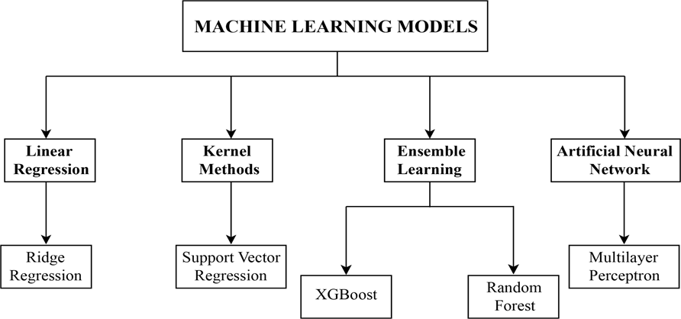
Figure. 1. Schematic representation of the ML models classification.

3.2.1 Ridge Regression (RR)
RR is a popular regression technique that is commonly used in data science and statistics [15]. It is a type of regularisation technique used in linear regression to prevent overfitting of the data. When dealing with multicollinearity, which is when two or more parameters in a linear regression framework are closely associated, it is especially helpful. In Ridge Regression, the cost function of ordinary least squares (OLS) is enhanced by a penalty component. It is roughly related to the regression model's coefficients' squared magnitude. The effect of this penalty is to shrink the coefficients towards zero, but not to zero, so that the model can still use all the variables, but with a reduced emphasis on those that are less important. This is called L2 regularisation. The hyper parameters for this model include the solver, which is the algorithm used to solve the optimization problem, alpha, which is essentially the regularisation strength and controls the shrinkage, and fit_intercept, which decides whether or not to add the intercept term to the model. The governing equation for Ridge Regression is:
$SSE= {‖y-Xβ‖}_{2}^{2}+{λ‖β‖}_{2}^{2}$ | (7)
where: $y$ is the target variable, $X$ is the feature matrix, $β$ is the vector of coefficients (weights) to be estimated and $λ$ is the hyper parameter controlling the strength of the L2 penalty.

3.2.2 Random Forest (RF)
RF regression is an extremely potent ML model [16] used for predicting the output of a continuous target variable based on a set of input features. It is a type of ensemble learning algorithm that aggregates various decision trees to forecast finally. This algorithm creates numerous decision trees by randomly sampling the input data as shown in Figure. 2.. After that, all of the individual trees' projections are added together to form the final forecast. Bootstrapping is a resampling technique used to create multiple training datasets from the original data. The technique involves randomly sampling the data with replacement to create a new dataset of the same size as the original, but with some of the observations repeated and others omitted. This process is repeated multiple times to create a set of training datasets. The functioning of this model can be read about in detail through the work of [17].
The important hyper parameters we have considered include n_estimators which specifies the number of decision trees to be built in the Random Forest. Increasing the number of trees generally leads to better performance, but it also increases the computational cost of the model. Also included is max_depth, which controls the maximum depth of each decision tree in the Random Forest. A deeper tree may fit the training data better, but it also increases the risk of overfitting.
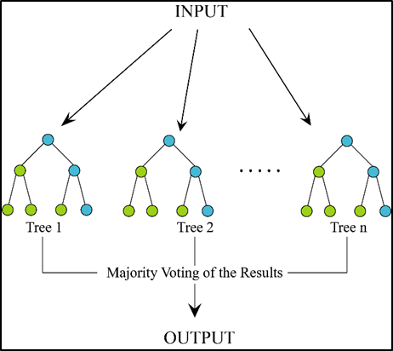
Figure. 2. Schematic illustration of working model for Random Forest.

3.2.3 Extreme Gradient Boosting (XGB)
XGB is a widely used machine learning technique [18], is used to forecast the outcome of a continuous target variable according to a collection of input data. It is an ensemble learning technique, much like RF, that combines a number of weak predictive models to produce a single, more reliable model. This is essentially the concept that is known as boosting. XGBoost uses something known as a base learner, which is also sometimes referred to as a weak predictive model, and is initially trained on the input data. Any machine learning technique, including decision trees or linear regression, can serve as the basis learner. In this study, a tree based learner is employed as shown in Figure. 3 [19]. As it aggregates the predictions of several weak models, it often yields very accurate predictions. This decreases bias and variance and raises the accuracy of the final prediction. It is an efficient and scalable method that can deal with massive datasets and features with several dimensions. It is rapid and efficient since it is optimised for parallel processing. The similarities and also the differences can be seen in the ways that RF and XGBoost are implemented, thus why they are both grouped under ensemble learning methods. They have similar hyper parameters too, namely max_depth and n_estimators. But, additional hyperparameters we intend to tune include learning_rate, which controls the step size or shrinkage rate at each boosting iteration, and colsample_bytree, which specifies the fraction of features to be considered for splitting at each internal node of each decision tree. A lower value can help reduce overfitting, but it may also lead to under-fitting, thus explaining the need to find the optimal value from a sample space.
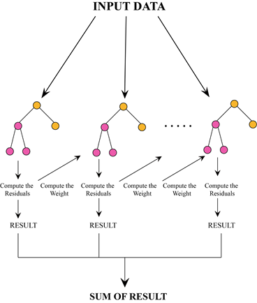
Figure. 3. Schematic illustration of the working of XGB model.

3.2.4 Support Vector Regression (SVR)
SVR is a popular machine learning algorithm used for regression tasks. It is based on the same principles as Support Vector Machines (SVM) used for classification tasks. It is one of the more popular ML models that have been implemented in mechanical engineering research and literature, due to its ability to handle high-dimensional datasets and noisy data. It can also handle both linear and nonlinear relationships between the input and output variables. Its goal is to find a hyperplane that maximises the margin between the predicted values and the actual values in the training set. Further reading on SVR can be done using the references [20].
However, SVR does come with its own limitations, namely in its difficulty in training data using non-linear kernels. It is mentioned in its documentation (sklearn) that the optimization problem of SVM is of quadratic order or beyond, and therefore can be impractical to implement past 10000 samples. Therefore, in this study, the linear kernel is used. The implementation can be thought of as a linear regression problem in the high-dimensional space. The linear kernel is less prone to overfitting than nonlinear kernels, and it also has a better generalisation performance. The hyper parameters included in optimising the SVR model include C, which controls the trade-off between achieving a low training error and a low testing error. A large value of C allows the model to fit the training data better, but may result in overfitting. Then there is epsilon, which controls the size of the insensitive zone around the regression line as shown in Figure. 5. The insensitive zone is the region where the error is ignored, and is used to make the model more robust to noise.
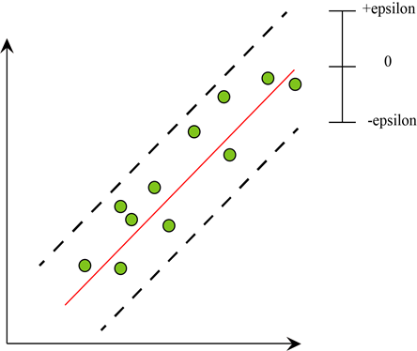
Figure. 5. Schematic illustration of the SVR model along with tolerance for error.

3.2.5 Artificial Neural Network (ANN)
Deep learning methods have been used for decades, with the first back propagation methods being detailed in 1970, which came to be instrumental in implementing Multilayer Perceptron (MLP). It is a type of ANN that has gained significant attention in recent years due to its ability to model complex nonlinear relationships between input and output variables [21]. It has been extensively implemented in Mechanical Engineering and Material Science literature due to its high accuracy and reliability in modelling complex systems. The basic theory behind MLPs is inspired by the structure and function of the human brain. An MLP consists of multiple layers of interconnected artificial neurons, where each neuron receives input signals, processes them, and generates an output signal. The neurons are organised into input, hidden, and output layers, with each layer containing multiple neurons.
The working of an MLP involves a training phase, where the weights and biases of the neurons are adjusted to minimise the error between the predicted output and the actual output. Backpropagation is a commonly used training algorithm for MLPs, where the error is propagated backwards from the output layer to the hidden layers and the input layer. The weights and biases of the neurons are then updated using gradient descent to minimise the error.
In the present work, the MLP has been implemented using keras, which is an API that acts as an interface for Tensor flow, which is essentially its backend. It is highly flexible and user friendly. A simple architecture was employed as shown in Figure. 6. There were 3 inputs and 1 output, thereby comprising the input and output layers. Two hidden layers were added, with 5 neurons each. This was done after much trial-and-error work with the digitised dataset of the larger dataset until steadily high results were obtained. The number of neurons per hidden layer was decided based on a rule of thumb that the number of hidden neurons should be less than twice the size of the input layer.
The activation function used for each neuron was ReLU (Rectified Linear Unit) and was decided based on extensive reading and implementation [22]. Based on previous works, the adam (Adaptive Moment Estimation) optimization algorithm was decided to be employed [23]. The hyperparameters that will be tuned for the MLP in this work are learning_rate, which determines the step size used in updating the weights during training. It controls how quickly the optimizer, in this case adam, adjusts the weights in response to the error gradient. The next one is dropout_rate, which is a regularisation technique used to prevent overfitting in MLP models. It works by randomly dropping out (setting to zero) some of the neurons in the hidden layers during training, thereby changing the architecture of the model. This helps to reduce the co-adaptation of neurons and encourages the network to learn more robust and generalizable features. It controls the probability of a certain neuron being dropped out.
The training of the network was done in a calculated manner, keeping in mind computational resources as well as overall efficiencies. For example, keeping the number of epochs as a hyper parameter need not give the best results as training for more than a certain number of epochs might result in the best possible model not being trained. Therefore, extensive reading had to be done so as to optimise the training process. The number of epochs were kept constant at 30. During the training, the data was further split such that 25% of the data was used to calculate a validation loss metric. An early stopping condition was kept such that during training, if the validation loss did not decrease for more than 5 epochs, training would be stopped. The weights from the least error obtained from the training done up until that point would be saved using a Model Checkpoint condition. Further reading on the intricacies of neural networks, its applications in engineering and further deep learning concepts can be obtained from the reference [24].
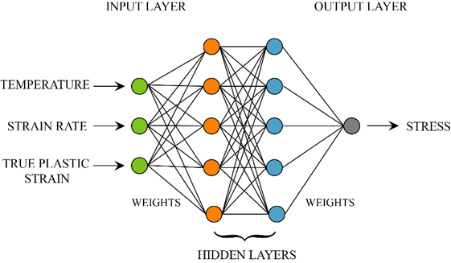
Figure. 6. Architecture of an MLP.

4. Experimental Details
In the present work, a 2 mm thick sheet was used in the as-received condition. The obtained material was characterised with X-ray fluorescence (XRF) spectroscopy for elemental composition test and the various important elements identified are Ti (79.62 %), Mo (13.86 %), Nb (2.67 %), Al (3.30 %), Si (0.308 %), V (0.170 %) and Fe (0.62 %).
Table. 1 Elemental composition of the as-received sheet material.
Elements | Al | Si | V | Fe | Ni | Nb | Mo | Ti
Weight (%) | 3.30 | 0.308 | 0.170 | 0.062 | 0.006 | 2.674 | 13.860 | 79.62

The uniaxial tensile tests were performed at various temperatures ranging from Room Temperature (RT) to 500 ºC with a gap of 100 ºC, and at a single strain rates of 0.0001, 0.001 and 0.01 S⁻¹ on a universal testing machine (Make: Zwick Roell, Germany; Model: Z100) as shown in Figure. 7. The test specimens were prepared in accordance with the ASTM E8/E8M-11 sub-size standard parallel to the sheet's rolling direction. To prevent oxidation during the testing at higher temperatures Delta Glaze was applied to the specimens. During the testing at higher temperature, a laser extensometer was used to measure the specimen's elongation.
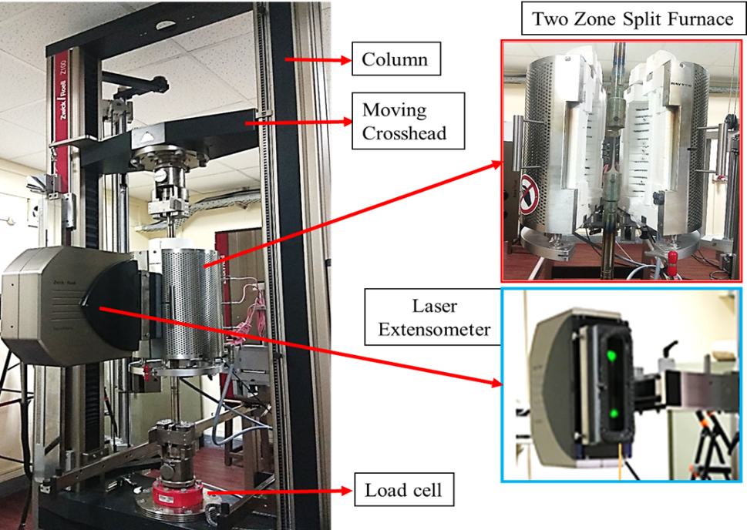
Figure. 7. Uniaxial tensile test setup loaded with high temperature furnace and laser extensometer.

The various constants of the m-ZA model were calculated based on the procedure mentioned in the [14] by incorporating the tensile test data obtained at different temperatures (RT to 500 ºC) and strain rates (0.0001, 0.001 and 0.01 S⁻¹). The calculated constants are presented in the Table. 1.

Table. 1. Material constants obtained for m-ZA model of β-21S alloy.
$C_{1}$ | $C_{2}$ | $C_{3}$ | $C_{4}$ | C₅ | $C_{6}$ | n
939.308 | 198.492 | 0.0004 | -0.0093 | -0.0055 | -0.00017 | 0.0783

The procedure for fitting and evaluation of the data has been clearly presented in the form of a flow chart shown in Figure. 8. The data is divided into training and testing data set so as to compare and contrast the full spectrum of usability of the model, allowing for a holistic view of the various ML models. The data was first cleaned such that only the plastic region data was considered and the true strains were converted to true plastic strain. The data for the different curves were then concatenated to a single dataset for learning. The workflow implemented for the various algorithms were kept consistent. The dataset was then divided 70/30 into training and testing sets. The training set was fed into a Grid Search CV algorithm for hyper parameter tuning. This was done along with k-fold cross validation, as to prevent overfitting, and where k = 10. Grid Search CV (Grid Search Cross-Validation) is a technique used in machine learning to find the best combination of hyper parameters for a given model. Hyper parameters are settings or values that are set before the model training process begins and are not learned from the data. Grid Search CV automates the process of tuning hyper parameters by exhaustively searching through a predefined grid of possible parameter values and evaluating the model's performance using cross-validation. In cross-validation, the data is divided into k subgroups, the model is trained on k-1 of these subsets, and its performance is assessed on the remaining subset. To obtain an average performance score, this process is carried out k times, utilising each subgroup only once for evaluation. Grid Search CV then selects the combination of hyper parameters that gives the best performance score across all cross-validation splits. By searching through a predefined grid of hyper parameters, Grid Search CV helps to avoid overfitting and ensures that the best possible model is selected. One of the benefits of Grid Search CV is that it automates the hyper parameter tuning process, saving time and reducing the risk of human error. It is a flexible and adaptable tool that could potentially be used with different kinds of machine learning models. The algorithm then returns the best parameters and are used to refit and retrain the model. This is done for a set seed value for reproducibility.
The model is then refitted and retrained on the best parameters. This model is then used to make predictions on the validation data, which is data at 150 °C and at a strain rate of 0.001 S⁻¹. This allows for comparison of the model's performance on data that is both identical to the training set's data and entirely distinct from it. The hyper parameter tuning and the model training has been done on CPU where the code is automatically parallelized using the parameter in Grid Search called n_jobs where it is set to -1, meaning that all the cores of the CPU will be utilised. This also means that more memory will be used along with an increasing number of cores used.

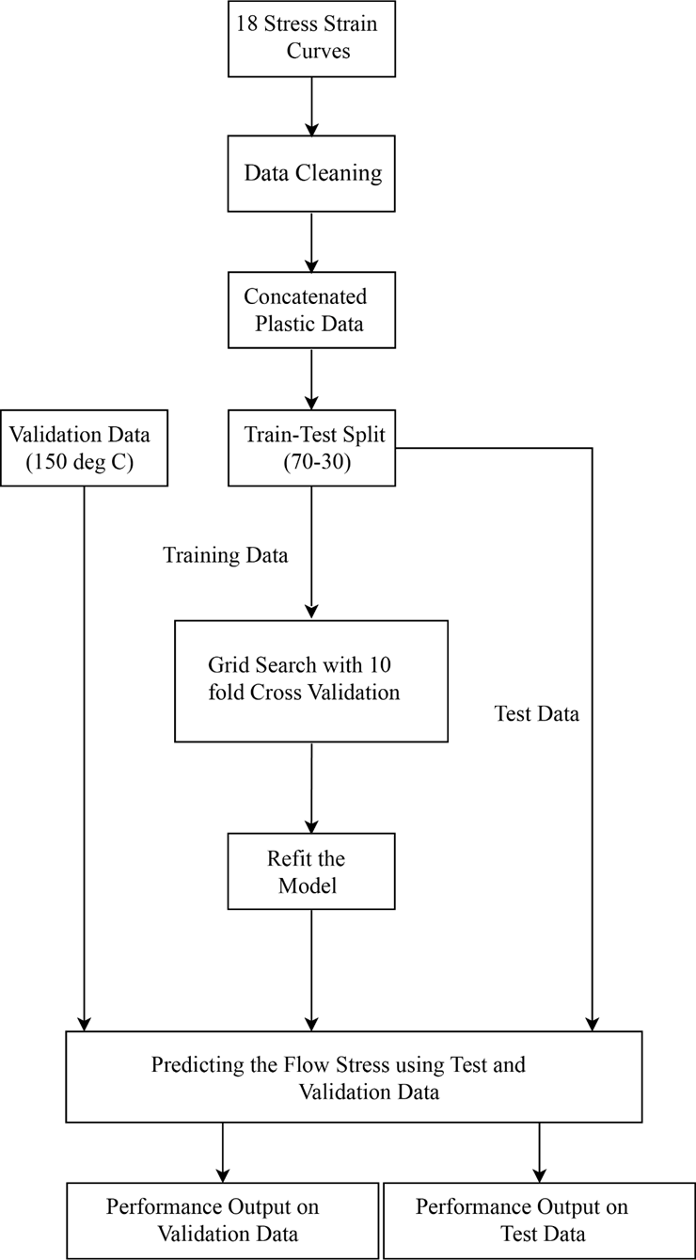
Figure. 8. Flow chart representing training and validation of data using ML models.

5. Results and Discussion
5.1 Experimental Flow Stress Behaviour
Figure. 9(a to c) shows the flow stress behaviour of the β-21S alloy when tested under different temperatures ranging from (RT to 500 ºC) and strain rates (0.0001, 0.001 and 0.01). It can be seen that with rise temperature RT to 300 ºC the flow stress of the material has reduced gradually. Thereafter, it has shown an improvement in the flow stress due to the strain hardening of the material with further rise in temperature from 300 ºC to 500 ºC at 0.0001 and 0.001 S⁻¹.

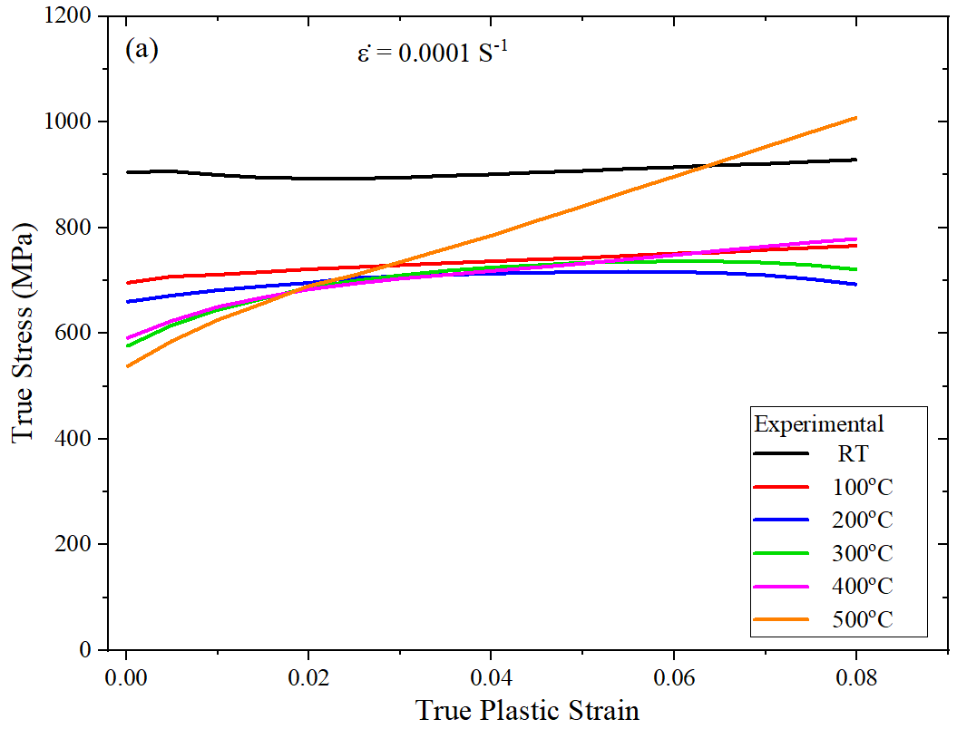 | 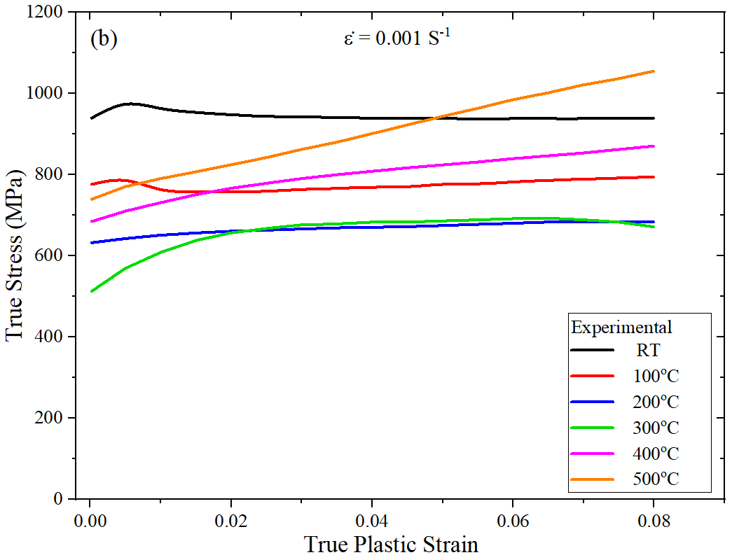
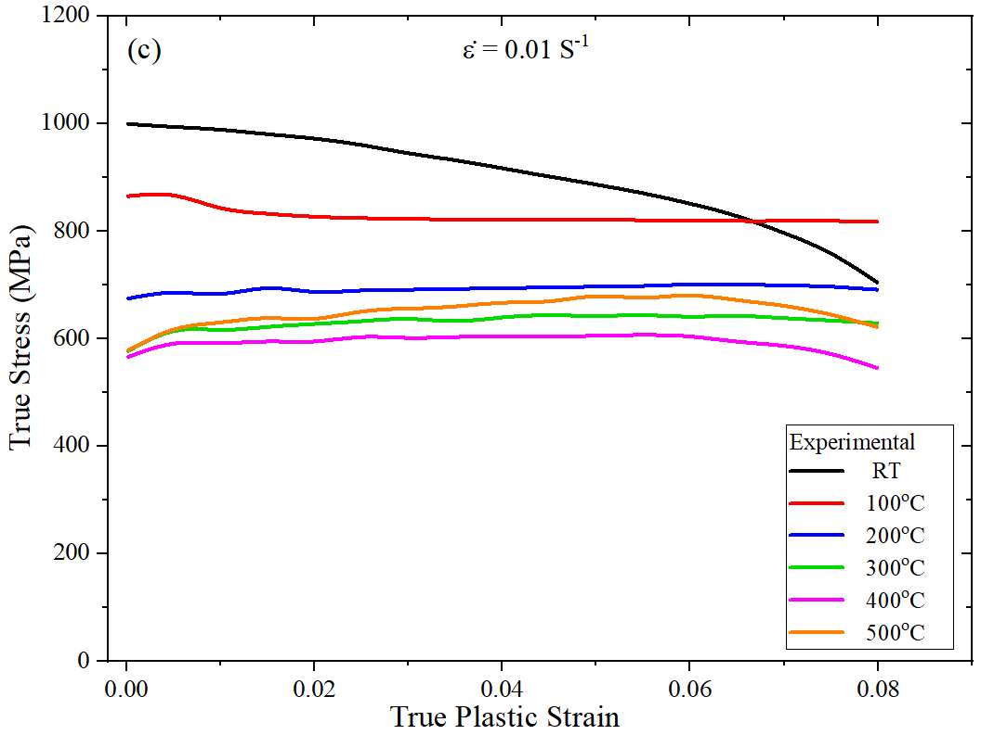
Figure. 9. True stress Vs true plastic strain plots of β-21S alloy at different temperature and strain rate conditions.

5.2 Flow Stress Prediction

The flow stress behaviour of the material has been predicted using the physical based modified Zerilli-Armstrong constitutive model and machine learning models on the validation data(150 ºC , 0.001 S⁻¹) as shown in the Figure. 10(a and b). Various constants of the m-ZA model calculated from the tensile test data have been used for the prediction of flow stress behaviour of the material at a particular test condition as shown in Figure. 10(a).
In case of the flow stress predicted using ML models, the hyper parameter space has been defined based on the available literature, recommendations from documentations as well as considering the available computational resources as shown in Table. 2. The concatenated dataset for training has been considered by taking the plastic data obtained at various test temperature and strain rates i.e., 18 curves gave us 162,759 samples. The inputs are temperature, strain rate and true plastic strain, whereas, flow stress is the targeted value. The results of the model used on the test data are presented in the Table. 3.

Table. 2. The hyper parameters and their space used during the training of the ML models.
Model | Hyper Parameters and Their Space | Best Parameters
ANN | 'learning_rate' : {0.001,0.01,0.1}  'dropout_rate ': {0.005, 0.1, 0.2} | 'learning_rate' : 0.001  'dropout_rate' : 0.1
SVR | 'C': {0.01, 0.1, 1, 10, 100, 500}  'epsilon' : { 0.001, 0.005, 0.01, 0.05, 0.1, 0.5, 1, 5, 10} | 'C': 0.01  'epsilon': 0.5
RF | ‘max_depth’ : {3, 6, 9, 12, 15}  ‘n_estimators’ : {10, 50, 100, 200, 500} | 'max_depth' : 15  'n_estimators' : 100
XGB | 'max_depth' : {3, 6, 9, 10, 12, 15}  'learning_rate' : {0.01, 0.05, 0.1, 0.3, 0.5}  'n_estimators’ : {10, 50, 100, 200, 500, 1000}  'colsample_bytree' : {0.3, 0.7} | 'max_depth' : 6  'learning_rate' : 0.3  'n_estimators' : 500  'colsample_bytree' :0.7
Ridge | 'alpha': {10, 1, 0.1, 0.01, 0.001, 0.0001, 0.00001, 0}  ‘fit_intercept’ : {True, False}  ‘solver’ : {'svd', 'cholesky', 'lsqr', 'sparse_cg', 'sag', 'saga'} | 'alpha' : 10  'fit_intercept' : True  'solver' : ‘saga’

Table. 3. Results of the ML models using the test data.
MODEL ACCURACY ON TEST DATA |  | Model
 |  | ANN | RF | XGB | Ridge | SVR
Measure Accuracy | MAPE [%] | 2.984 | 0.119 | 0.367 | 11.790 | 11.436
 | Reduced Chi Squared | 0.534 | 0.002 | 0.012 | 11.209 | 10.079

It is observed that the performance of RFR is much worse on new data compared to its performance on the test set. While it seems like an issue of overfitting, it stems from a larger problem that affects various models. Random Forest models can only extrapolate within the set of data it was trained on. It can only draw inferences that are an average of labels that have already been observed. The highest and lowest labels in the training data will therefore confine the model's predictions in regression situations. This can be problematic when the range or distribution of the prediction inputs differs from that of the training data. This phenomenon is known as covariate shift. Random Forest models are particularly susceptible to this issue because they lack the ability to extrapolate beyond the observed data. Therefore, when making predictions on new data, the model is more reliable in capturing the overall shape of the data rather than producing precise extrapolated values.
SVR and Ridge gave relatively poor results and are thus not recommended. However, if computational resources and time permits, further experimentation can be done using nonlinear kernels for SVR. However, as mentioned in previous sections, they need not give much better results and perhaps, the effort and computational time will still persist as mentioned before and so, it may be wise to look into the other ML models that give better results and that too more efficiently.
From the results, it is observed that XGBoost and then ANN, give the best results consistently on the testing as well as validation data. While XGBoost gives the lowest MAPE value, giving the smallest reduced chi squared value does not necessarily mean that it is a better model. A reduced chi squared value closer to 1 generally indicates a much better fit to the data, an ability to learn underlying patterns of the given data and also generalizability. A very small reduced chi squared value can also indicate noisy results. Choosing one model over the other comes down to preference or even the availability of computational resources. Training the XGBoost model required significantly less time as compared to the deep learning approach and also gave a lower MAPE value. Meanwhile, the ANN model gave less noisy results and also acceptable and high accuracy.
The XGBoost model works so well due to the gradient boosting involved, giving a much optimised result as well as the regularisation methods applied. Further research can be done looking into the boosting family of algorithms, including development of novel algorithms based on the boosting principle. ANNs have long shown an impressive ability to model complex and nonlinear relationships using large amounts of data, making them so popular. The model is also optimised and regularised to give the best possible performance.

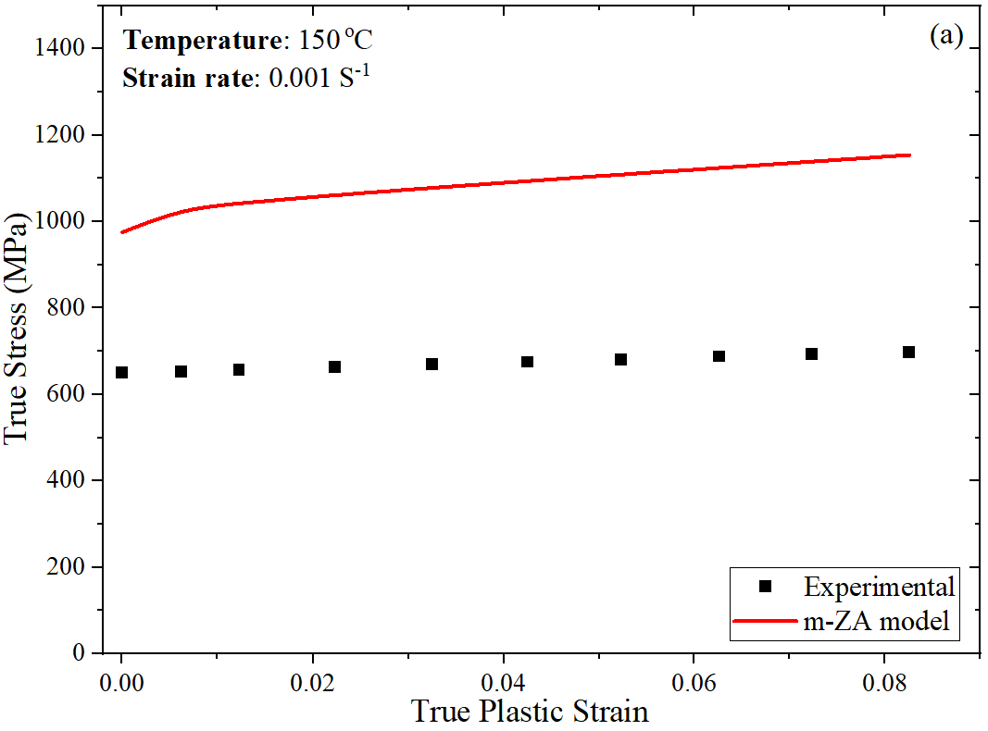 | 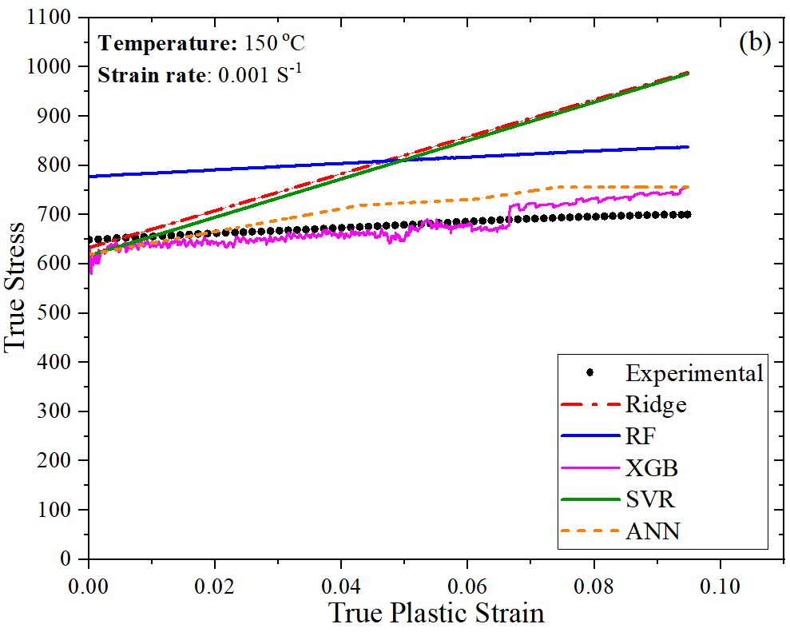
Figure. 10. The flow stress of β-21S predicted using (a) m-ZA and (b) various ML models.

5.3 Validation of Results
The present work makes use of two evaluation metrics, namely mean absolute percentage error (MAPE) and Reduced Chi-Square. By quantifying the percentage difference between the actual and predicted values, the MAPE has been used to gauge how accurately a model can predict values. Mathematically, MAPE is represented as shown in the Equation. 8.
$MAPE= \frac{100}{n}\sum_{t=1}^{n}{}\left|\frac{A_{t}-F_{t}}{A_{t}}\right|\%$ | (8)
Reduced chi-squared is a goodness-of-fit metric commonly used in statistical analysis and machine learning to assess the quality of a model's fit to the data. It is defined as the ratio of the chi-squared ($χ^{2})$ statistic to the degrees of freedom ($υ$) of the model.
$χ_{υ}^{2}=\frac{χ^{2}}{υ}$ | (9)
First, the chi-squared statistic is obtained, which is the sum of the squared differences between the observed data ($O_{i})$ and the predicted data ($C_{i})$, divided by the expected data as shown in the Equation. 10.
$χ^{2}=\sum_{i}{}\frac{{(O_{i}- C_{i})}^{2}}{σ_{i}^{2}}$ | (10)
The chi-squared value is then divided by $υ$, in the model to get the Reduced Chi-Square score. $υ$ is the difference between the number of sample observations and the number of features that the model is trained on. Taking both MAPE and Reduced Chi-Square to evaluate ML models gives complementary information about the performance of the model. A lower MAPE value indicates a more accurate model, and MAPE is often used as a benchmark metric for these types of applications. Reduced Chi-Square, on the other hand, provides a normalised measure of the goodness of fit of the model, which is independent of the number of data points used to train the model. A lower Reduced Chi-Square value indicates a better fit of the model to the data, and it can be used to determine whether the model is overfitting or under-fitting the data.

Figure. 9(a and b) shows the statistical comparison of predicted flow stress with that of the experimental one. From Figure. 9(a), it can be seen that the MAPE has been found to be higher than predicted using a physical based m-ZA model compared to the different ML models. The lowest MAPE of 3.18% has been found for XGB followed by ANN with 5.5% which are found to be more efficient in prediction compared to other models. Whereas, in Figure. 8(b), the reduced chi-square value was found to be lowest for XGB with 0.41 followed by ANN with 0.99. Based on the two different statistical parameters, it can be inferred that the XGB model has shown a better prediction of the flow stress compared to all other models.

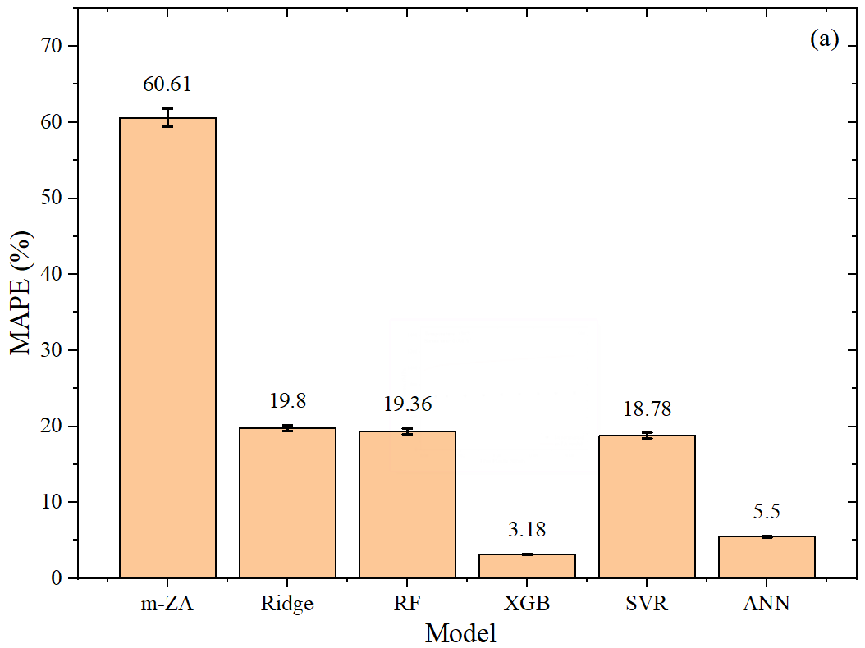 | 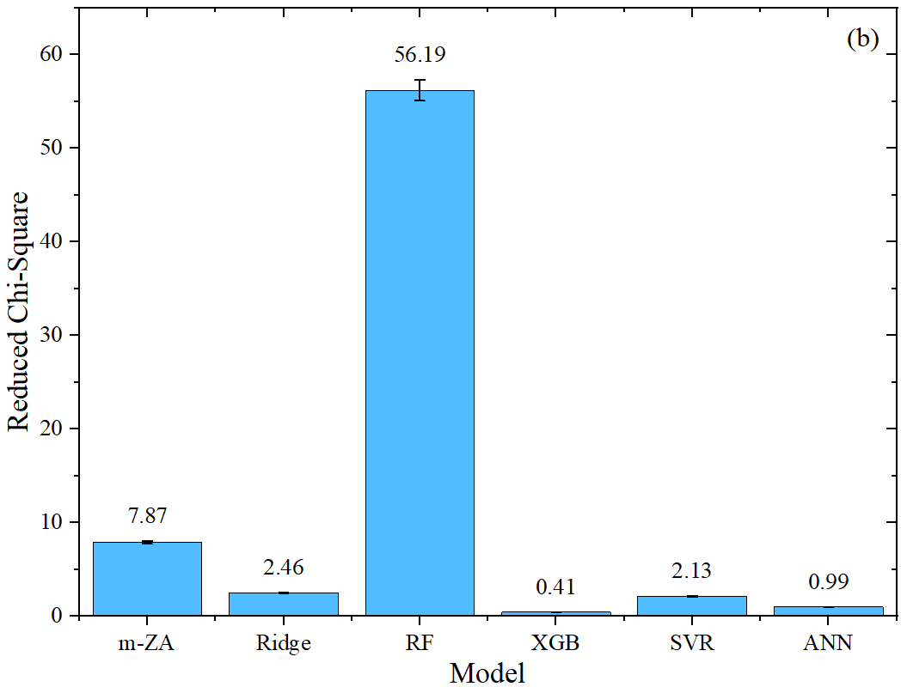
Figure. 9. Statistical comparison of predicted flow stress obtained from different models with the experimental.

5. Conclusions
The present work has reported the investigation on the flow stress behaviour prediction of β-21S using a physical based constitutive model and various machine learning models. The important outcomes regarding the prediction efficacy of various models are summarised below.
- The experimental flow stress behaviour of β-21S alloy has been investigated in the temperature range of RT to 500 ºC and at different strain rates (0.0001, 0.001 and 0.01 S⁻¹). The flow stress behaviour hasn’t followed any trend during deformation under different test conditions. The flow stress has found to be reduced with rise in temperature till 300 ºC along with strain softening and thereafter it has shown significant rise in the flow curve which can be due to the strain hardening.
- The physical based m-ZA model has been established well for prediction of the flow stress based on the tensile test data. But, the flow stress predicted using the m-ZA model has shown a MAPE of 60.61% and reduced chi-square value of 7.87%.
- Various machine learning models have been implemented to model the flow stress behaviour of the β-21S alloy. The ML models have shown better performance than the physical based m-ZA model when compared using statistical parameters. XGB and ANN in particular have shown the best results, owing to their reliable and optimised architectures, giving MAPE of 3.18% and 5.5% each and reduced chi squared values of 0.41 and 0.99 each which is far lesser compared to other models.

References

[1] L.-Y. Chen, Y.-W. Cui, and L.-C. Zhang, “Recent Development in Beta Titanium Alloys for Biomedical Applications,” Metals, vol. 10, no. 9, p. 1139, Aug. 2020, doi: 10.3390/met10091139.
[2] S. Hémery, P. Villechaise, and D. Banerjee, “Microplasticity at Room Temperature in α/β Titanium Alloys,” Metall. Mater. Trans. A, vol. 51, no. 10, pp. 4931–4969, Oct. 2020, doi: 10.1007/s11661-020-05945-4.
[3] O. M. Ivasishin, P. E. Markovsky, Yu. V. Matviychuk, S. L. Semiatin, C. H. Ward, and S. Fox, “A comparative study of the mechanical properties of high-strength β-titanium alloys,” J. Alloys Compd., vol. 457, no. 1–2, pp. 296–309, Jun. 2008, doi: 10.1016/j.jallcom.2007.03.070.
[4] C.-M. Li et al., “Research progress on hot deformation behavior of high-strength β titanium alloy: flow behavior and constitutive model,” Rare Met., vol. 41, no. 5, pp. 1434–1455, May 2022, doi: 10.1007/s12598-021-01861-7.
[5] O. Lypchanskyi, T. Śleboda, A. Łukaszek-Sołek, K. Zyguła, and M. Wojtaszek, “Application of the Strain Compensation Model and Processing Maps for Description of Hot Deformation Behavior of Metastable β Titanium Alloy,” Materials, vol. 14, no. 8, p. 2021, Apr. 2021, doi: 10.3390/ma14082021.
[6] C. Li, Z. Ding, and S. van der Zwaag, “The Modeling of the Flow Behavior Below and Above the Two‐Phase Region for Two Newly Developed Meta‐Stable β Titanium Alloys,” Adv. Eng. Mater., vol. 23, no. 1, p. 1901552, Jan. 2021, doi: 10.1002/adem.201901552.
[7] O. Kramer, “Scikit-Learn,” in Machine Learning for Evolution Strategies, in Studies in Big Data, vol. 20. Cham: Springer International Publishing, 2016, pp. 45–53. doi: 10.1007/978-3-319-33383-0_5.
[8] R. Liang, R. Yu, Y. Luo, and Y. Zhang, “Machine learning of weld joint penetration from weld pool surface using support vector regression,” J. Manuf. Process., vol. 41, pp. 23–28, May 2019, doi: 10.1016/j.jmapro.2019.01.039.
[9] M. Sharifzadeh, A. Sikinioti-Lock, and N. Shah, “Machine-learning methods for integrated renewable power generation: A comparative study of artificial neural networks, support vector regression, and Gaussian Process Regression,” Renew. Sustain. Energy Rev., vol. 108, pp. 513–538, Jul. 2019, doi: 10.1016/j.rser.2019.03.040.
[10] J. Stendal, M. Bambach, M. Eisentraut, I. Sizova, and S. Weiß, “Applying Machine Learning to the Phenomenological Flow Stress Modeling of TNM-B1,” Metals, vol. 9, no. 2, p. 220, Feb. 2019, doi: 10.3390/met9020220.
[11] J. Decke et al., “Predicting Flow Stress Behavior of an AA7075 Alloy Using Machine Learning Methods,” Crystals, vol. 12, no. 9, p. 1281, Sep. 2022, doi: 10.3390/cryst12091281.
[12] G.-M. Cao, Z.-W. Gao, and X.-Y. Gao, “Predicting flow stress of Ni steel based on machine learning algorithm,” Proc. Inst. Mech. Eng. Part C J. Mech. Eng. Sci., vol. 236, no. 8, pp. 4253–4266, Apr. 2022, doi: 10.1177/09544062211048175.
[13] Y. C. Lin and X.-M. Chen, “A combined Johnson–Cook and Zerilli–Armstrong model for hot compressed typical high-strength alloy steel,” Comput. Mater. Sci., vol. 49, no. 3, pp. 628–633, 2010.
[14] J. Li, F. Li, J. Cai, R. Wang, Z. Yuan, and G. Ji, “Comparative investigation on the modified Zerilli–Armstrong model and Arrhenius-type model to predict the elevated-temperature flow behaviour of 7050 aluminium alloy,” Comput. Mater. Sci., vol. 71, pp. 56–65, 2013.
[15] N. Amigo, S. Palominos, and F. J. Valencia, “Machine learning modeling for the prediction of plastic properties in metallic glasses,” Sci. Rep., vol. 13, no. 1, p. 348, Jan. 2023, doi: 10.1038/s41598-023-27644-x.
[16] M. Murugesan et al., “Supervised Machine Learning Approach for Modeling Hot Deformation Behavior of Medium Carbon Steel,” Steel Res. Int., vol. 94, no. 2, p. 2200188, Feb. 2023, doi: 10.1002/srin.202200188.
[17] M. R. Segal, “Machine Learning Benchmarks and Random Forest Regression”.
[18] M. H. Bae, M. Kim, J. Yu, M. S. Lee, S. W. Lee, and T. Lee, “Enhanced processing map of Ti–6Al–2Sn–2Zr–2Mo–2Cr–0.15Si aided by extreme gradient boosting,” Heliyon, vol. 8, no. 10, p. e10991, Oct. 2022, doi: 10.1016/j.heliyon.2022.e10991.
[19] T. Chen and C. Guestrin, “XGBoost: A Scalable Tree Boosting System,” in Proceedings of the 22nd ACM SIGKDD International Conference on Knowledge Discovery and Data Mining, San Francisco California USA: ACM, Aug. 2016, pp. 785–794. doi: 10.1145/2939672.2939785.
[20] H. Drucker, C. J. C. Burges, L. Kaufman, A. Smola, and V. Vapnik, “Support Vector Regression Machines,” in Advances in Neural Information Processing Systems, M. C. Mozer, M. Jordan, and T. Petsche, Eds., MIT Press, 1996. [Online]. Available: https://proceedings.neurips.cc/paper_files/paper/1996/file/d38901788c533e8286cb6400b40b386d-Paper.pdf
[21] M. Murugesan, M. Sajjad, and D. W. Jung, “Hybrid Machine Learning Optimization Approach to Predict Hot Deformation Behavior of Medium Carbon Steel Material,” Metals, vol. 9, no. 12, p. 1315, Dec. 2019, doi: 10.3390/met9121315.
[22] K. Hara, D. Saito, and H. Shouno, “Analysis of function of rectified linear unit used in deep learning,” in 2015 International Joint Conference on Neural Networks (IJCNN), Killarney, Ireland: IEEE, Jul. 2015, pp. 1–8. doi: 10.1109/IJCNN.2015.7280578.
[23] R. N. Singarimbun, E. B. Nababan, and O. S. Sitompul, “Adaptive Moment Estimation To Minimize Square Error In Backpropagation Algorithm,” in 2019 International Conference of Computer Science and Information Technology (ICoSNIKOM), Medan, Indonesia: IEEE, Nov. 2019, pp. 1–7. doi: 10.1109/ICoSNIKOM48755.2019.9111563.
[24] S.-H. Song, “A Comparison Study of Constitutive Equation, Neural Networks, and Support Vector Regression for Modeling Hot Deformation of 316L Stainless Steel,” Materials, vol. 13, no. 17, p. 3766, Aug. 2020, doi: 10.3390/ma13173766.

